Registering for ProStart Educator Access

ServSafe Note: ProStart and ServSafe are hosted on the same NRA database, so you can use the same account (username and password) to keep all records under one profile. This can help to avoid confusion of mixing up multiple accounts.
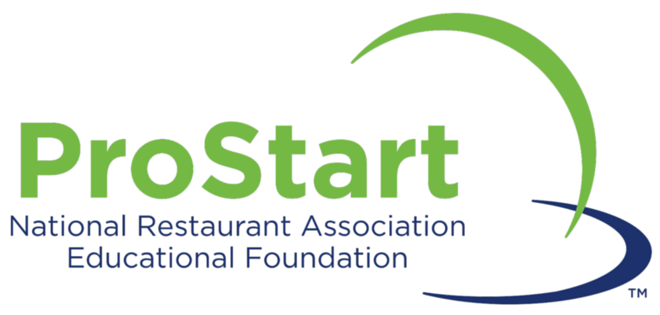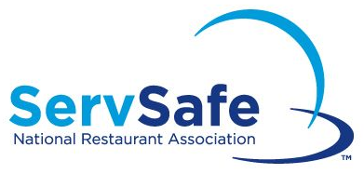

Go to www.chooserestaurants.org. On the top right corner, you will find hyperlinks for ‘Login’ and ‘Register’. If you already have a ServSafe account select ‘Login’ and enter your previously created login credentials. If you have never created an account with NRA or NRAEF, select ‘Register’ to create an account.

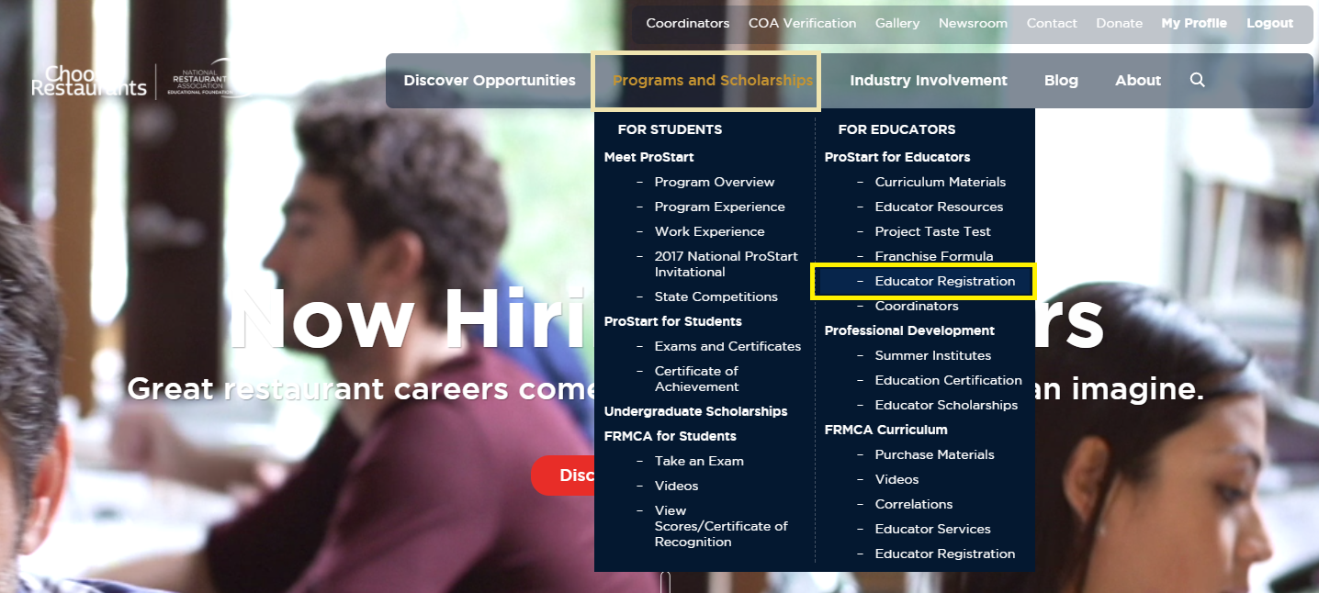
Next proceed to the ‘Programs and Scholarships’ tab and select ‘Educator Registration’ from the right side of the dropdown. This additional registration is necessary since the website is used by ProStart students who do not get access to Educator specific materials.
Identify the type of Educator access needed and click ‘Select’ to begin the registration process. There are four categories available with different levels of access.  *If you are uncertain which category you need, please refer to the ProStart Role Decision Tree. | 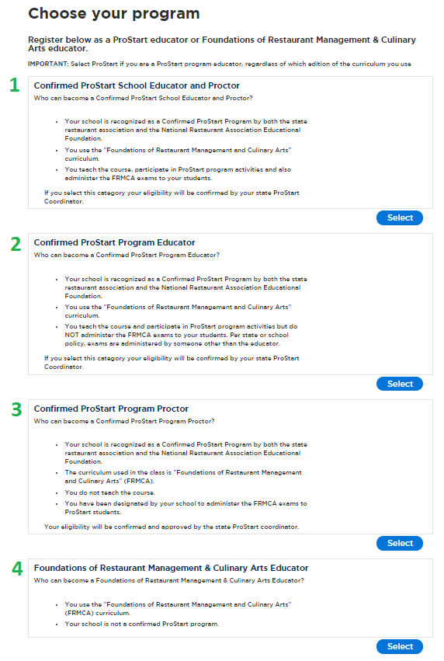

After you have selected the type of Educator access needed, you can select your school from the dropdown menu.
If your school is not listed, you will need to submit a School Request. Please notify your state ProStart Coordinator so they can work with the Service Center to get it approved. You will then be notified that you are clear to proceed with the Educator Registration again.

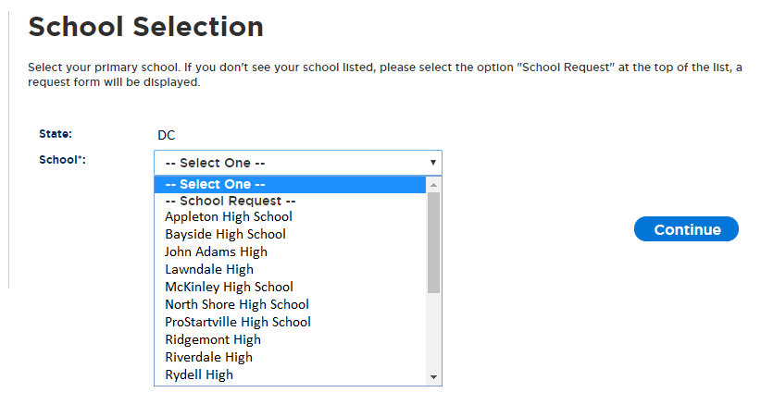

Next, enter the requested information to the best of your ability. If you do not know the number of students yet, an estimate will suffice.
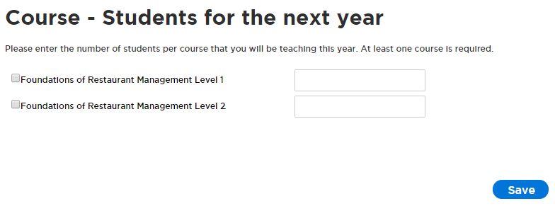
Read the Performance Agreement and check off each of the requirements to be able to accept.
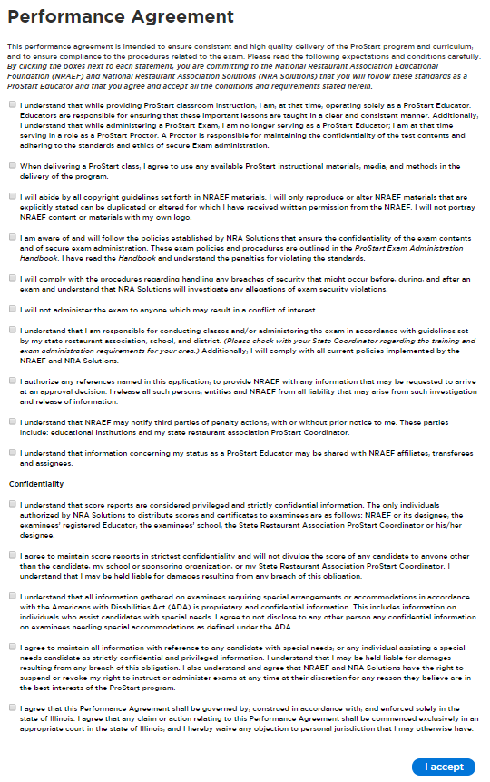
Once you accept the agreement, your application is complete. Please notify your state ProStart Coordinator so they can work with the Service Center to get it approved. You will receive a confirmation email to the email address on file notifying you when you have the requested access.
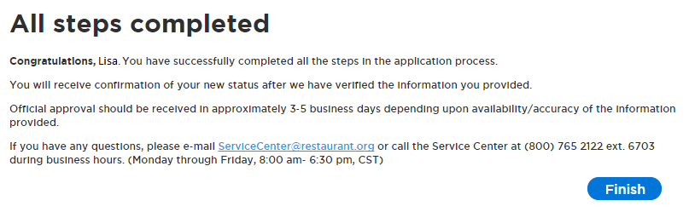

Final Note
You only need to complete this registration process one time to sign up. Your access will remain unchanged from school year to school year provided you and your school comply with program standards.

